

**USE OF OHMMETER, ammeter and voltmeterMEASUREMENTS IN D.C.**

***Team 8***



Members:

* Soriano Montiel Bryan Andrés
* Montaño Ayala Alan Israel
* Vargas Romero Erick Efraín

Teacher: Durán Camarillo Edmundo René

Learning unit: Fundamental analysis circuit

Practice: 01

Sequence: 1CM14

Semester: 2016 – 2017 “A”

Index

1. OHMMETER 3

1.1 HOW TO USE THE OHMMETER 3

2.1 HOW TO USE THE VOLTMETER 5

3. Ammeter 6

3.1 HOW TO USE THE AMMETER 6

4. CALCULATIONS AND OPERATIONS 7

Measuring resistive values chart: 01 7

Voltage Measurement chart: 02 7

Current Measurement chart: 03 8

5. Questionnaire 9

6. Conclusions 10

Conclusion by member 10

**Soriano Montiel Bryan Andrés** 10

Montaño Ayala Alan Israel 10

**Vargas Romero Erick Efraín** 10

7. Bibliografías 11

# **1. OHMMETER**

An ohmmeter is an instrument for measuring electrical resistance.

The design consists of a small battery for applying a voltage to measure low resistance, and then, by means of a galvanometer, measuring the current flowing through the resistor.

The scale of the galvanometer is not calibrated directly in the unit ohm because, under the law of Ohm, when the voltage of the fixed battery, the circulating current through the galvanometer only depend on the value of resistance, this it is less resistance too higher current and vice versa.

There are also other types of ohmmeters more accurate and sophisticated in which the battery has been replaced by a circuit which generates a constant current

According to the instructions of our ohmmeter, test a circuit with energy can "damage the device, circuit and “yourself ". You can find other instruments are called Auto range.

## **HOW TO USE THE OHMMETER**

1 - What to do when starting is completely or cut off all power to the circuit you are going to try. You must have a circuit or wire completely off, so that they have an accurate measurement and can assure you protection. The ohmmeter will give power to the circuit voltage and, therefore, no other type of energy is not necessary.

2nd - Choose a suitable ohmmeter for your project. Analog ohmmeters are very basic and inexpensive and, in general, have a range varying from 0-10 to 0-10000 ohm, while digital ohmmeter ranges may have similar or have a "auto ranging" resistance reading your device or circuit and select the correct range automatically. See Figure 1.1.1

3rd - Connect the test leads into the sockets of the meter. For multifunctional meters, you will see a "positive" plug and a negative or "common" plug. These plugs can also be recognized by a distinctive colour that they possess, which are red black (+) and (-).

4th - Set the meter to zero if you have a dial zero adjustment. Note that the scale read in the reverse direction of most conventional measuring scales, ie read right lower resistance and better resistance to the left. Zero resistance should be observed when sensors are connected directly to each other. Keep them together and turn the dial to "fit" until the needle on the scale is at zero ohms so that this adjusted since.

5th - In order to start the measurement, we board a sensor at one end of a circuit, do the same with the other sensor and the other end. Aim the instrument reading. If you have a 1000 ohm resistor, you can place a sensor in each conductor resistance. Select the range of 1000 or 10000 ohms, then read the meter to see if read 1000 ohms.

6th - Now, isolates the components of the electrical circuit of hardwiring for you to try individually. If you read ohms of resistance on a printed circuit board, you have to unsolder or tear resistance so that you make sure you do not get a misreading through another reading on the circuit.

7th - Read the resistance of a cable or a branch of a circuit for you to see if there is any open or short circuit in the fissure. If you read "infinite ohms", then there is a reading to follow the electric current and, in simple terms, this suggests that a component is burning somewhere in the circuit or that there is a broken conductor. Many circuits have devices "door" (or semiconductor transistors), diodes, capacitors, however, may not read continuity even when the entire circuit is intact, which makes it difficult to prove only complete circuits with an ohmmeter.

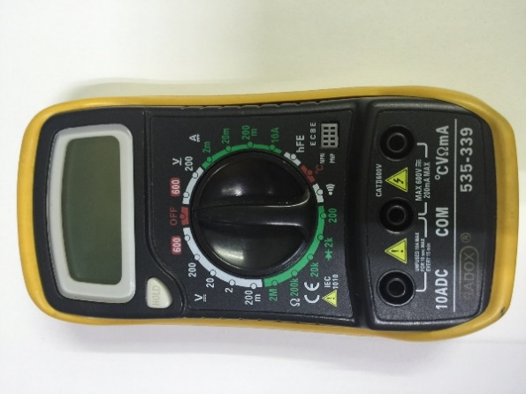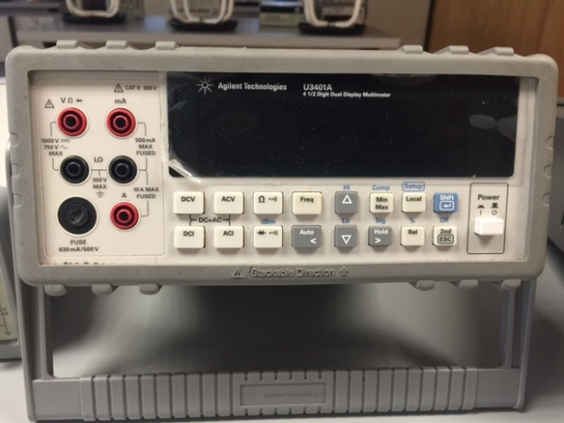8 ° - Turn off the ohmmeter when not in use. Sometimes the test leads can be shorted when storing the device. **2. VOLTMETER**

Figure 1.1.1

These devices give a numerical indication of tension, usually on an LCD type display. They often have additional features such as memory, peak value detection, auto range and other features.

The system as such instruments used are techniques of analogue-digital conversion (usually using a double ramp integrator) to obtain the numerical value displayed on a digital LCD screen.

The first digital voltmeter was invented and produced by Andrew Kay of "Non-Linear Systems" (and later founder of Kaypro) in 1954.Figura 2.1

## **2.1 HOW TO USE THE VOLTMETER**

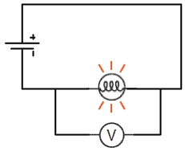

To perform the measurement of the potential difference voltmeter this should be placed in parallel (See Figure 2.1.1); it’s shunt on the points between which we try to make the measurement. This leads us to understand that the voltmeter must possess the highest possible internal resistance, in order to not produce appreciable consumption, which would result in inaccurate measurement of the voltage. To do this, in the case of based on electromagnetic effects of the electrical current instruments, shall be equipped with coils of very thin wire with many turns, which with low current through the device when needed is achieved for the movement of the pointer.

Figure 2.1.1

At present there are digital devices which function voltmeter presenting characteristics quite high isolation using complex isolation circuitry.

In some cases, to allow measurement of higher stresses to which withstand the windings and mechanical parts of the apparatus or electronic circuits in the case of digital, they are given a resistance of high value placed in series with the voltmeter, for so this is subjected to only a fraction of the total voltage.

Figura 1.2

# **3. Ammeter**

An ammeter is an instrument used to measure the intensity of current that is flowing through an electrical circuit. A micro ammeter is calibrated in millionths of an ampere and a millimetre in thousandths of an ampere.

In general, the ammeter is considered a simple galvanometer (instrument that detects small amounts of current), with a resistor in parallel, called "shunt resistance". Having a range of shunt resistors may have an ammeter with several measuring ranges or intervals. Ammeters have a very low internal resistance below 1 ohm, in order that their presence does not decrease the current to be measured when connected to an electrical circuit.

Ammeters currently use an analogue / digital converter for measuring the voltage drop across a resistor through which current flows to be measured. Reading converter is read by a microprocessor that performs calculations to display on an LCD display the value of the electric current circulating.

## **3.1 HOW TO USE THE AMMETER**

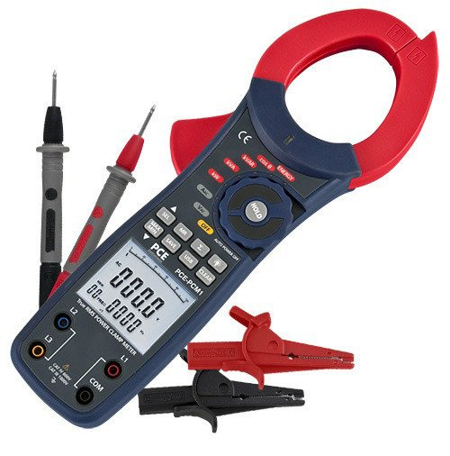To measure, it is necessary that the intensity of the current flowing through the ammeter (See Figure 3.1.1), so it should be placed in series, and so this is crossed by said current. The ammeter must have an internal resistance as small as possible in order to avoid a significant voltage drop (being small will give you a better way to power and so this will be measured more effectively). To do this, in the case of electromagnetic effects based on electric current instruments are provided with thick wire coils and with few turns.

Figure 3.1.1

Sometimes, to allow far higher than those borne by the delicate windings and mechanical apparatus without damage intensities, they are provided with a resistor of a small value, positioned in parallel with the winding, doing so only through a fraction mainstream. This additional resistor is called a shunt. Although most of the current passes through the resistance, the amount flowing through the meter is proportional to the total intensity at the galvanometer can be used to measure strengths of several hundred amperes.

The clamp is a special type of ammeter that obviates the inconvenience of having to open the circuit in which you want to measure the intensity of the current.

Figura 1.2

# **4. CALCULATIONS AND OPERATIONS**

## **Measuring resistive values chart: 01**

|  |  |  |
| --- | --- | --- |
| Resistances | Measurement with digital ohmmeter | Value with colour code |
| R1 | 1.018 KΩ | 1 KΩ |
| R2 | 325 Ω | 330 Ω |
| R3 | 556.7 Ω | 560 Ω |
| R4 | 655.7 Ω | 680 Ω |

## **Voltage Measurement chart: 02**

|  |  |  |  |
| --- | --- | --- | --- |
| Voltage source | Digital multimeter | | |
| R1 and R2 voltage | Voltage R1 | Voltage R2 |
| E=1V | 0.9979 | 0.7515 | 246.4 |
| E=2V | 1.9976 | 1.5 | 493 |
| E=3V | 2.9969 | 2.2566 | 0.7401 |
| E=4V | 3.9962 | 3.0093 | 0.9878 |
| E=5V | 4.9954 | 3.7611 | 1.2339 |
| E=6V | 5.994 | 4.5137 | 1.48 |
| E=7V | 6.993 | 5.263 | 1.7281 |
| E=8V | 7.993 | 6.017 | 1.9754 |
| E=9V | 8.989 | 6.768 | 2.22 |
| E=10V | 9.98 | 7.519 | 2.47 |
| E=11V | 10.98 | 8.27 | 2.71 |
| E=12V | 11.98 | 9.022 | 2.96 |

## **Current Measurement chart: 03**

|  |  |  |  |
| --- | --- | --- | --- |
| Voltage source | Digital multimeter | | |
| Current through R1 and R2 | Current through R1 | Current through R2 |
| E=1V | 2.47 mA | 1.51 mA | 1.31 mA |
| E=2V | 4.95 mA | 3.025 mA | 2.62 mA |
| E=3V | 9.85 mA | 4.53 mA | 3.93 mA |
| E=4V | 13.15 mA | 7.13 mA | 6.05 mA |
| E=5V | 16.45 mA | 8.91 mA | 7.57 mA |
| E=6V | 19.75 mA | 10.70 mA | 9.09 mA |
| E=7V | 23.07 mA | 12.49 mA | 10.62 mA |
| E=8V | 26.38 mA | 14.29 mA | 12.14 mA |
| E=9V | 29.71 mA | 16.01 mA | 13.67 mA |
| E=10V | 33.04 mA | 17.91 mA | 15.18 mA |
| E=11V | 36.36 mA | 19.73 mA | 16.69 mA |
| E=12V | 39.72 mA | 21.4 mA | 18.27 mA |

# **5. Questionnaire**

1° What is the characteristic of a series circuit?

*Its components are connected only by one of its terminals and a single node*

2° What is the characteristic of a parallel circuit?

*These are connected by both of its terminals*

3° What is the main difference between an analogue and a digital meter?

*Analog meter has a galvanometer, while digital meter has an LCD screen*

4° Why should not an ammeter connected in parallel?

*If this were connected in this way, the current would fail to pass this device and it would not be possible to calculate what you want*

5° Why you should deenergize the circuit when an electrical circuit resistance measured?

*It’s de-energized because the device tends to throw a charge, and if we don’t deenergize the circuit it’s possible change the result.*

# **6. Conclusions**

*We could notice physical differences between circuits in series and in parallel as well as the shape shown in diagrams.*

*It was realized in a practical way the correct use of current measuring devices.*

*Recognition of colour coded resistors to identify them more easily.*

## **Conclusion by member**

### **Soriano Montiel Bryan Andrés**

*It has achieved greater clarity in the use of measuring instruments, in addition to better recognize such instruments.*

*You can get an idea of how it is made a circuit on a breadboard and just looking at the diagram that represents it. Also we begin to familiarize ourselves with the colour code to identify the resistors and also know the capacity of each of them.*

## **Montaño Ayala Alan Israel**

*With the results of the lab, we can conclude that the colour system for resistance gives us a close value to their actual value. It could also be observed as in the series circuit source voltage equals the resistors and the higher the resistance value higher the voltage in it.*

### **Vargas Romero Erick Efraín**

*With these results we can see what has been learned in class, complement the theoretical part and to describe the various measuring instruments at our disposal, we use give a correct handling of the device. In addition, the use of colour coding for resistance that is fundamental to know and behaviour that have strengths depending on how they are connected.*

# **7. Bibliografías**

Charles Alexander. (2006). Fundamentos de Circuitos. Mexico: McGraw-Hill Interamerica.

Thomas L. Floyd. (2007). Principios de Circuitos Eléctricos. México: Pearson.